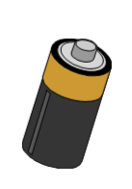
NO TECHNOLOGY DAY
Electricity Unit
Harkins Middle School
Science, Grade 6 Name:________________________________________________________________________________

How much to do you depend on electricity and technology throughout the day?
In the first column below, describe how you use electricity and technology during a typical day.
In the second column, describe how you were able to change your routine to participate in our “No Technology Day”.

Typical Day  Date:_____________________________________ |  | No Technology Day  Date:_____________________________________
6-8am |  | 6-8am
8-10am |  | 8-10am
10-12noon |  | 10-12noon
12-2pm |  | 12-2pm
2-4pm |  | 2-4pm
4-6pm |  | 4-6pm
6-8pm |  | 6-8pm
8-10pm |  | 8-10pm

