Exploring Arthropods
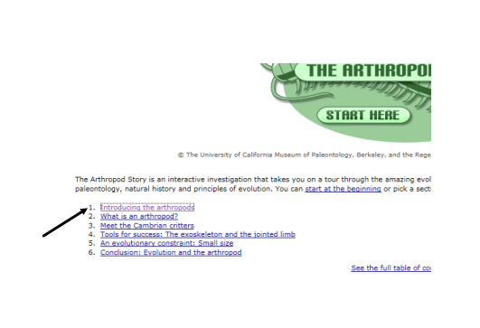
1. Go to : http://tolweb.org/treehouses/?treehouse_id=3923
2. Click on : “Introducing the Arthropods”

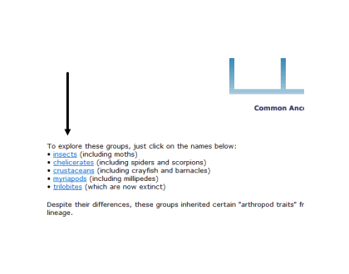
3. Click through the interactive pages (doing the activities) until you reach the page: 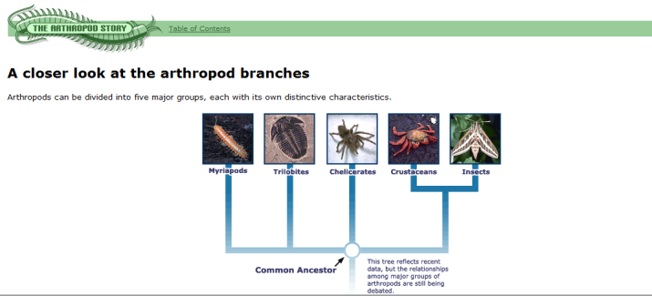

4. Explore each of the Arthropod categories listed
(* Notice that millipedes, centipedes and arachnids are referred to as: myriapods, trilobites and chelicerates)
5. Choose an organism from one of the following groups: Crustacean, Arachnid or Insect.
You will be creating a presentation to teach the class about this organism. Please have your organism chosen for next Science class. There will be a sign-up sheet so that no two people are teaching about the same organism so have one or two back-up organisms ready

