Shopping Spree!!!
- You’ve won a gift card! With your money, you can choose any of the items posted around the room.
- The object is to try to spend as much of your gift card as possible because it expires in 2 days.
- You will need to calculate the Sale Price of the item you wish to buy AND add 13% tax to the item.
- Record all of your calculations on the back of this sheet.

Example:
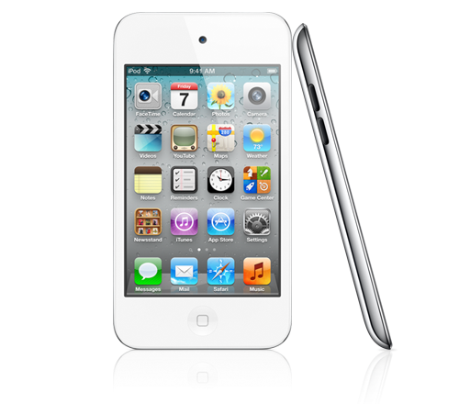
Regular Price: $200
Save: 18%

Calculations:
Sale Price: 0.18x200 = $36, 200-36 = $164 Sale Price
Add Tax: 164 x 1.13 = $185.32
If you won a $500 Gift card, you now have 500-185.32 = $314.68 left to spend.

Calculations
Gift Card amount: ____________
Name of Item | Regular Price | Sale Price Calculations | Money left on Gift Card

