**December 7th 2011 Lesson**

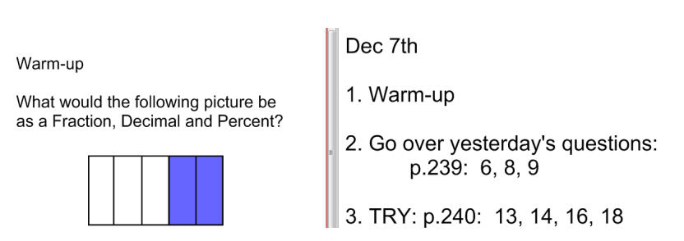

**December 8th 2011 Lesson**

